

CS361: Assignment 6: Sprint 2 Plan (for Microservice A)

Overview
Plan the microservice you’ll make for your teammate(s). That includes defining how to request and receive data from the microservice.

Instructions
Complete each item below by replacing the highlighted text (Usability note: double-click the text to select it).
- What is your Sprint Goal? (e.g., fully implement the spell-checker microservice) The Sprint Goal must clearly communicate what the microservice will do.
Fully Implement the budget calc microservice. This service will perform 3 functions. 1 will be converting currency, 2 will be determining top expense category, and 3 will be generating a financial summary.

- Define at least three user stories for this Sprint. Provide your user stories and their functional and non-functional acceptance criteria (and associated quality attributes).
Requirements for Microservice A:
- You must implement at least three user stories.
- Each user story must have a name.
- Each user story must use the “As a… I want to... so that…” format.
- Each user story must have at least one functional acceptance criterion.
- All functional acceptance criteria must use the “Given… when… then…” format.
- At least one of the user stories must have an associated quality attribute and non-functional acceptance criterion.

First user story
(Front of index card)
Calculate Financial Summary

UserStoryFormat(As a user, I want to calculate a summary of my income and expenses over a selected time period so that I can understand my financial status. )
(Back of index card)
Acceptance criteria

Functional requirements
- Given that I have recorded transactions, when I send records from a certain time frame to the microservice, then the microservice should return the total income and total expenses for that period.

Quality attributes & Non-functional requirements
- The summary data should be returned within 5 seconds of the request.
- The service should provide accurate results with an average 99% success rate.

Second user story
(Front of index card)
View Top Expense Categories

UserStoryFormat(As a user, I want to calculate my top expense categories so that I know where I spend most of my money.)
(Back of index card)
Acceptance criteria

Functional requirements
- Given that I have categorized expense transactions, when I send my expenses and their categories to the microservice then the microservice should return a ranked list of categories based on the total amount spent in each.

Quality attributes & Non-functional requirements

Third user story
(Front of index card)
Currency Conversion calculator

UserStoryFormat(As a user, I want to convert currency so that I can understand my finances in a familiar or preferred currency.)
(Back of index card)
Acceptance criteria

Functional requirements
- Given that I have transactions recorded in the default currency, when send an amount and the requested currency type to the microservice, then the microservice should return the converted amount.

Quality attributes & Non-functional requirements

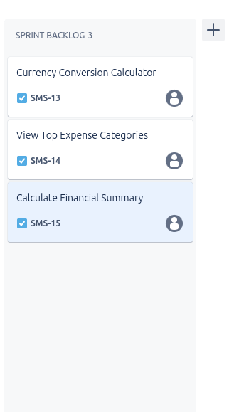
Take a screenshot that shows you’ve moved these user stories into a Sprint Backlog in your task management system.

- What kind of communication pipe will the microservice use? (e.g., text files, REST API)
REST API

- How will other programs be able to request data from the microservice and what request parameters will be required? Give an example call using pseudocode or actual code.

Request parameters (included parameters in the request call)
For financial summ: JSON records, price
For top expense: JSON expense, price, category
For currency convert: JSON amount, fromType, toType

Detailed description (how data will be requested)
The data will be requested from the main program by performing an HTTP Post request at the desired endpoint and passing the associated JSON data to process in the request.

Example call (pseudocode or actual code)
url= “http.www.example.com/api/financialSum”
request = { “expense”: “tile floor”, “price”: “256”, “category”: “home upgrades”}
response = requests.post.(url, json=request)
this will vary among the different operations the microservice can perform Each will have its own endpoint. e.g. /financialSum, /topExp, /currenConv.
- How will other programs be able to receive data from the microservice and what data will the microservice provide? Give an example call using pseudocode or actual code.

Data type (what type of data will be provided, e.g. JSON, string, etc)
Data will be returned from the microservice in JSON
Detailed description (how data will be provided)
Given data is passed as JSON or other (see above) via a HTTP post request to the microservice’s endpoint, the microservice will process the data, perform the necessary operations based on the endpoint used and return the results as JSON back to the main program via HTTP request.
Example call (pseudocode or actual code)
if response.status_code == 200:
finSum = response.json()

This would be a good time to make a new repository to house the microservice.

Submission
PDF or Word format via Canvas.
You must follow instructions at Modules > “Attach a Document to "Text Entry" Field”.

Grading
You are responsible for satisfying all criteria listed in the Canvas rubric for this assignment.

Questions?
Please ask via Ed so that others can benefit from the answer.

